**Project Title:**

**Northwest Gaming App**

**Project Graduate Directed Project Team**

|  |  |  |
| --- | --- | --- |
| **Name of the team member** | **Roles** | **Contact Information** |
| Sumana Reeddy Bathula | Project Manager | S538395@nwmissouri.edu |
| Roith Reddy Avisakula | Team Leader | [S538294@nwmissouri.edu](mailto:S538294@nwmissouri.edu) |
| Rajashekar Gande | Full Stack developer | [S538099@nwmissouri.edu](mailto:S538099@nwmissouri.edu) |
| Pooja Gundu | UI Developer | [S538295@nwmissouri.edu](mailto:S538295@nwmissouri.edu) |
| Sumanth Reddy Naidu | Backend Developer | [S538395@nwmissouri.edu](mailto:S538395@nwmissouri.edu) |
| Vikas Baswapuram | Database Engineer | [S538336@nwmissouri.edu](mailto:S538336@nwmissouri.edu) |

* **Statement of Purpose**

The main purpose of this app is to create a socially distant game for students of Northwest Missouri State University that introduces the bearcats to special areas of the campus and have fun and supports teamwork while keeping the players healthy during this pandemic situation.

* **Overview**

In this project we want to create an app that is playable on a mobile device. The app would encourage players to complete a 'quest' by finding a particular list of locations.

A player should activate one of the questing locations.The user must enter the geographic area (as determined by its mobile device) to score the location. Locations can be identified explicitly

(easier) or represented using (harder) clues. The quest can require the access to locations in a specific order-or in any order defined by the creator of the quest.

Points may be won on:

1. Player arriving at a location.

2. A player doing a search.

Points for a completed quest is based on sum of the location points earned along with a completion bonus and also based on the time taken to complete the quest.

* **Functional Requirements:**

**ADMIN**

Dr. Charles Hoot is the admin of the website of our project plays an important role in setting up the challenges to the students who are users of the application. The admin uses the website to create the teams. The Dr. Charles Hoot can also monitor the past data of the user by viewing the history page where the past weeks challenges and statistics are displayed. He can also download the data in the form of excel sheet.

* **USERS:**

The user is a person or a player who has signed up for the game.

Any person who signs p for the game is defined as the user in this game.

* **Benefits:**

This game helps the players in the physical activity as the player have to walk around to find the locations.

This also helps the users to build a healthy competition thereby bringing the people together.

* **Epics / User Stories / Tasks (Jira):**

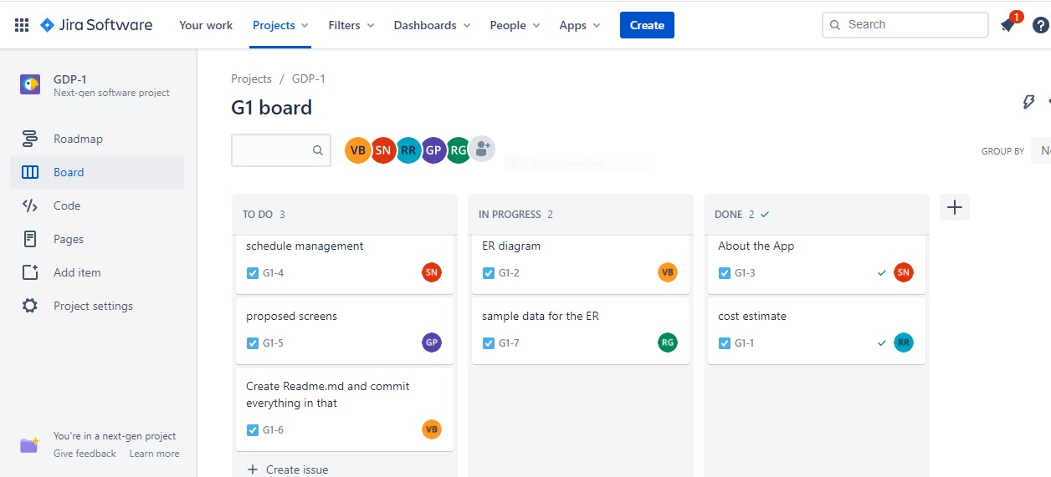

* **Acceptance criteria checklist**
* **Contract scope / budget / schedule (2 semesters)**

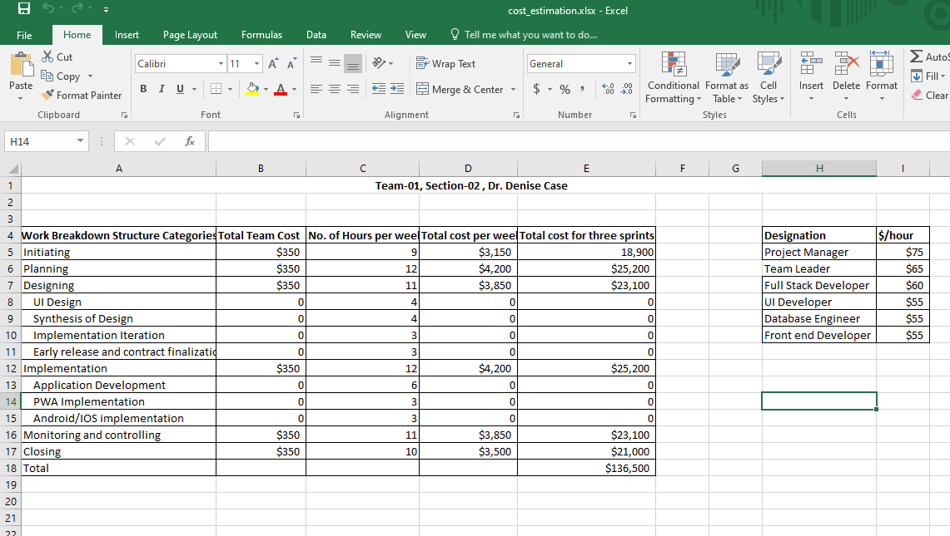

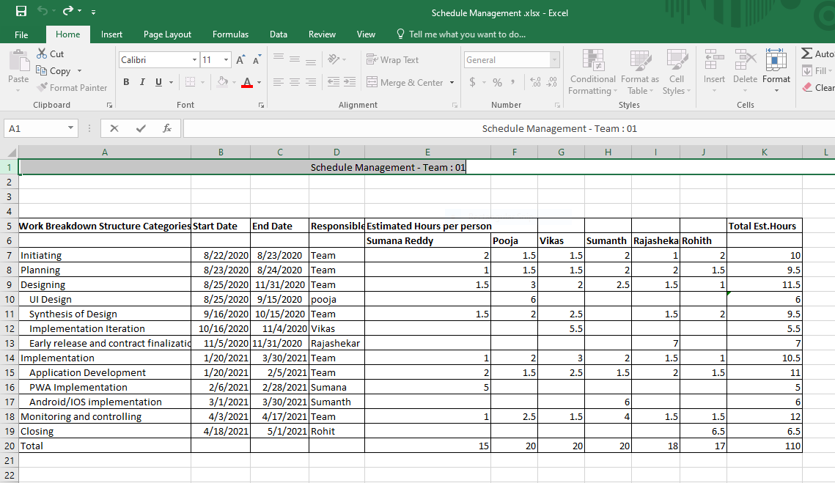

* **Proposed Home Page:**

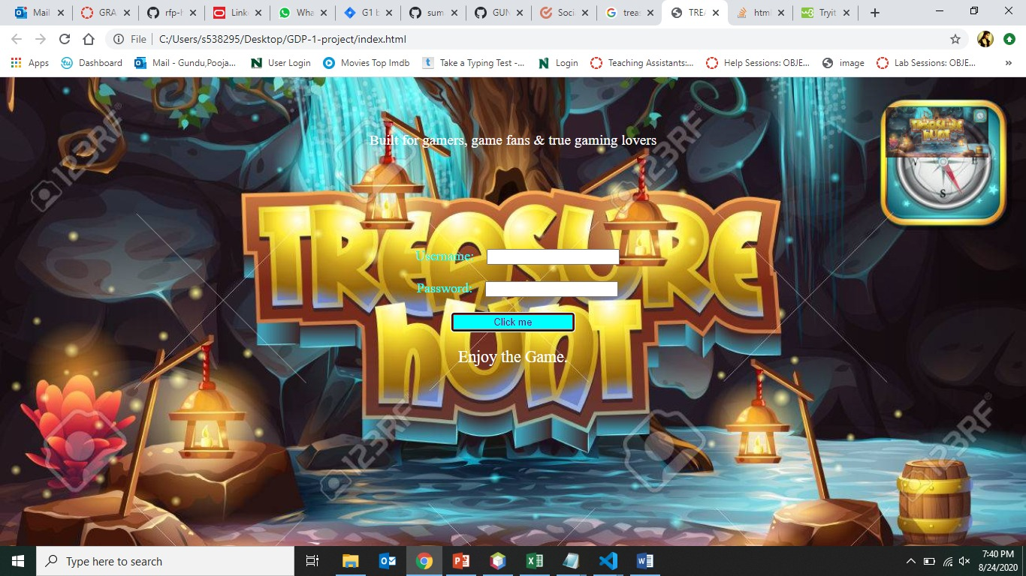

* **Technology stack descriptions**

This app will be developed using the PWA.

The technologies expected to be used are:

HTML

CSS/BootStrap

JavaScript

* **E-R diagram displayed :**

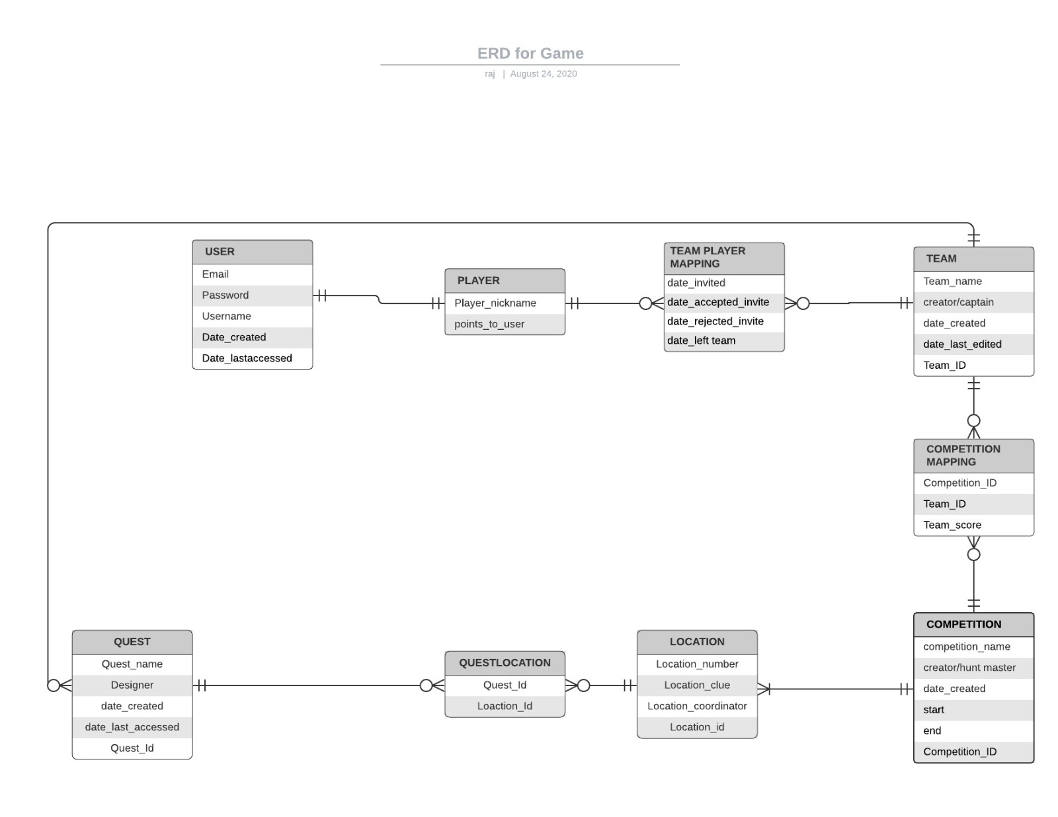

* **Consistent set of sample data in Excel, use one sheet for each entity**

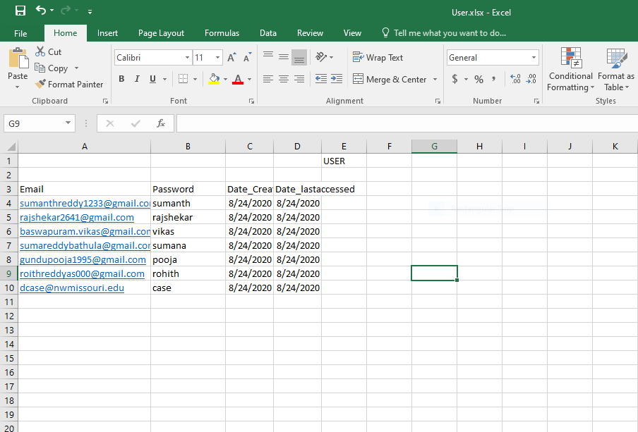

* **Risks and assumptions**

This application is based on the locations and to find the location accurately GPS is used, this could be a challenging task to code in.

This game is based on finding the locations which are outdoor and the given the present circumstances social distancing must be followed in this game.